
C.E.P. Rigoberto Fontt Izquierdo
Idioma Extranjero Inglés.
Prof. Jaime Landa

Guía de aprendizaje # 5 Segundo Medio _____

Name: ______________________________________________________________ Date:____________________

Objectives:
1. Apply previous knowledge about Simple past theory.
2. Identify form and function of grammatical structure “used to/ didn’t use to”
3. Organize the new information.
4. Resolve through doing exercises.
5. Talk about past events.
Contents:
Grammar: Simple past.

I. Study the grammar and answer the question according to this rules.
I  You  He  She  We  They |  | Used to  Didn’t use to |  | live in the country.
Did | you  they  he  she |  | use to live in the country?

1. Choose the correct option.
Grandpa: About 100 years ago people__________________________ride horses. Used to / didn’t use to
They _________________________________take the bus like we do now. Used to / didn’t use to
Pam: I know. Did they __________________________________ cook on a stove, grandpa? Used to / didn’t use to
Grandpa: Of course not! They__________________________________ cook over wood fires. Used to / didn’t use to
Pam: Really? What else grandpa?
Grandpa: Well, people___________________________ write letters, they______________________________ send telegrams instead.
Just fifty years ago, they started writing letters. Used to / didn’t use to
Pam: And of course they ___________________________________send text messages or chat online either. Used to / didn’t use to
Life _____________________________be really difficult back then! Used to / didn’t use to
used to / didn't use to / anymore
2. Complete the dialogue using the words below.

Joe: Hi, Mia. I'm Joe. Welcome to the suburbs.
Mia: Hi Joe, thanks. Wow, people are really nice here.
Joe: Yeah, people are pretty friendly. How do you like the suburbs?
Mia: I like it here. I _____________________________ live downtown, but it was pretty busy.
Joe: I bet it was! You don't have to worry about it.
Mia: I know. I ______________________________like all that noise.
Joe: I know what you mean. I ______________________________ live in a big city too.
Mia: Really? I'm glad you don't live there_______________________
Joe: Me too. I really love to live in the suburbs. It's so quiet!
Mia: Did you _______________________________ feel bored when you first moved here?
Joe: At first, I did, but now I can't imagine myself living anywhere else.

3. Make questions
Play computer games write stories walk to school wake up early meet with friends study at weekends
Ride a bike watch horror movies use cell phone swim in the beach smoke cigarettes
climb mountains walk the dog cook the dinner listening to music visit museums visit your grandparents
a._Did you use to write stories
b.___________________________________________________________
c. ___________________________________________________________

d. ___________________________________________________________,
e. ___________________________________________________________
f. ___________________________________________________________

g. ___________________________________________________________,
h. ___________________________________________________________
i. ___________________________________________________________
j. ___________________________________________________________,
k. ___________________________________________________________
l. ___________________________________________________________

4. Molly Hornby was a young girl in the 1960s. Read what she says about it.

“I was a young girl in the 1960s. My friends and I used to do a lot of things which shocked our parents. We used to do things our mothers never did. We cut our hair, we wore short skirts, we smoked, and went dancing. We danced to the music of Elvis Presley and the Beatles. We also got the chance to see the Beatles live at a concert once. It was amazing. My father went fishing once a week. He always wished that I would accompany him, but fishing was not my cup of tea. Instead my friends and I went for picnics in the surrounding area quite often. My boyfriend had a car, a 1960 Ford Falcon, so he always picked us up and we often drove to Brighton. We went to the pictures twice a week and I loved to watch films with Marlon Brando and Elizabeth Taylor, especially the ‘Reflections in a Golden Eye’ starring both of them. I still love to watch this film. It’s my favorite. I can remember it all so clearly.”
RIGHT or WRONG
Read and answer what Molly Hornby used to do when she was young.
Molly Hornby …
…used to do a lot of things which shocked her parents. ____________________
…used to cut our hair. _______________________
…used to wear long skirts. _____________________________
…used to sing Elvis Presley songs. _____________________________
…went to a Beatles’ concert once. __________________________
…used to go fishing with her father. __________________________
…used to go for picnics in the surrounding area quite often. __________________________
…used to drive to Brighton with her friends and boyfriend. ___________________
…used to go to the pictures twice a week. _____________________
…used to watch films with Marlon Brando and Elizabeth Taylor. ______________________

5. Have a look the text you are going to read. Where do you think it was extracted from?
Why do you think so?
a. A novel. b. A play c. a report d. d. a short story

The school that was our school before the railroad came and overthrew it was a particular sort of place. It was a school of some celebrity in its neighborhood, but nobody could say why.
Our School was remarkable for white mice. We used to keep red-polls, linnets, and even canaries, in desks, drawers, hat-boxes, and other strange refuges for birds; but white mice were the favorite stock. The mice were the occasion of some most ingenious engineering, in the construction of their houses and instruments of performance.
The boys used to train the mice much better than the masters trained the boys. I recall one white mouse, who used to live in the cover of a Latin dictionary, who ran up ladders, drew Roman chariots, shouldered muskets, and turned wheels. He had the misfortune to mistake his way in a triumphal procession to the Capitol, when he fell into a deep inkwell, and was dyed black and drowned.
The usher at our school, who we considered to know everything as opposed to the Chief, who we considered to know nothing, was a bony, gentle-faced, clerical-looking young man in rusty black.
We all liked him, for he had a good knowledge of boys. He was a writing master, mathematical master, English master, mended the pens, and did all sorts of things. He always used to call at parents’ houses to inquire after sick boys, because he had gentlemanly manners. He was rather musical, and on some remote day he had bought an old trombone and made the most extraordinary sounds when he sometimes tried to play it of an evening. In the summer vacations he used to take pedestrian excursions with a knapsack; and at Christmas time, he used to go to see his father at Chipping Norton.
There was a fat master who used to come in a gig, and taught the more advanced matters; and there was a little French master who used to come in the sunniest weather, with a handleless umbrella. There was, besides, a serving man whose name was Phil. He mended whatever we broke, and made whatever we wanted. He was general glazier, among other things, and mended all the broken windows. One time, when we had the scarlet fever in the school, Phil nursed all the sick boys of his own accord, and was like a mother to them.
Adapted from: Dickens, C. (n.d.). Our School. Retrieved 02/08, 2013, from ttp://www.readbookonline.net/readOnLine/2519/
6. Read the words in the Key Word Spot and match them with these pictures. You can use a dictionary, if necessary.
Key Word Spot
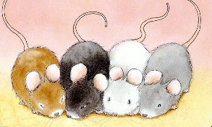
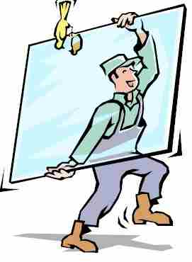

- Red-poll:

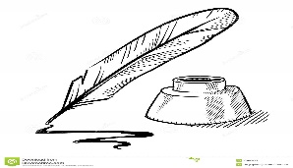
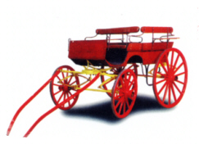
- glazier:

- usher:

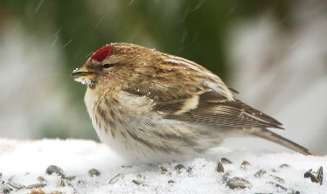
- Musket:
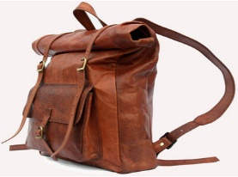
- Inkwell:

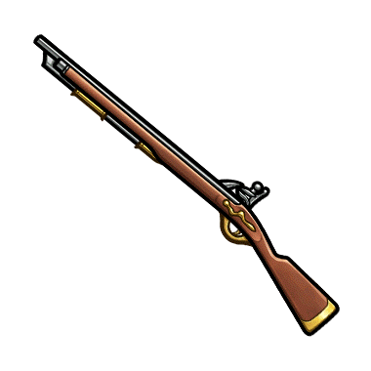
- Knapsack:
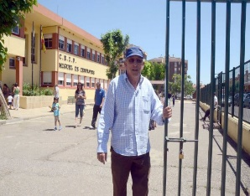
- Gig:

h. Mice:
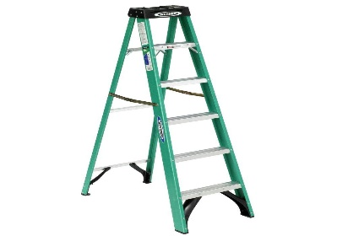
i. ladder:

7. Read the text carefully again and answer the following questions.
a. What did students at this school use to keep?
____________________________________________________________________________
b. What happened to the most famous white mouse?
_____________________________________________________________________________
c. Who did the students like most?
____________________________________________________________________________
d. What did the usher use to do on vacations?
______________________________________________________________________________
e. How did the French master use to get to school?
______________________________________________________________________________
f. Who was Phil?
________________________________________________________________________________
8. Read the text once more. Find the words in bold in the text in the text (a – e) and match them with their meanings (i – v).
a. Our school was remarkable for white mice.
b. I recall one white mouse, which used to live in the cover of a Latin dictionary.
c. He always used to call at parents’ houses to inquire after sick boys.
d. He used to take pedestrian excursions with a knapsack.
e. He was general glazier, among other things, and mended the broken windows.
i. ______ A person whose job is to fit glass into frames of windows.
ii. ______Ask about.
iii. ______Remember.
iv. ______Unusual.
v. ______Walking and not traveling in a vehicle.
9. Create original sentences affirmative or negative ones according to your own experience.
(You can use the verbs bellow)
When I was a little child?
a. I didn’t use to watch horror movies. (-)
b. I used to clean my room. (+)
c. ___________________________________________________________

d. ___________________________________________________________,
e. ___________________________________________________________
f. ___________________________________________________________

g. ___________________________________________________________,
h. ___________________________________________________________
i. ___________________________________________________________

j. ___________________________________________________________,
k. ___________________________________________________________
l. ___________________________________________________________

Play computer games write stories walk to school wake up early meet with friends study at weekends
Ride a bike watch horror movies use cell phone swim in the beach smoke cigarettes go to the gym
climb mountains walk the dog cook the dinner listening to music visit museums visit my grandparents
clean my room

